­

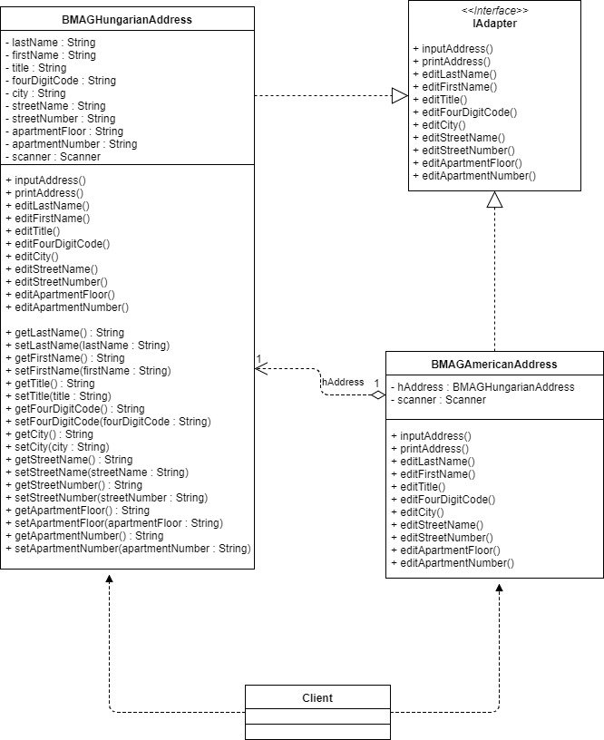

**Pseudo-Code**

**BMAGAmericanAddress.java:**

* BMAGAmericanAddress(BMAGHungarianAddress)

Verify that the zip code is in standard zip (xxxxx) or zip +4 (xxxxx-xxxx) notation. If it is not, alert the user and call the appropriate method to correct the zip code.

Verify that the city and state is in the proper notation (City, State). If it is not, alert the user and call the appropriate method to correct the city and state info.

* inputAddress()

Prompt for and receive input from the user for each field in a standard American address.

Allow the user to enter “null” for the apartment floor field. This should indicate to the function that no other apartment fields need to receive input (the address is not an apartment).

* printAddress()

Print the address in the standard format:

“Title” “First Name” “LastName”

FL “Apartment Floor” APT “Apartment Number”

“Street Number” “Street Name”

“City, State” “Zip Code”

If “null” was entered for the apartment floor print this format instead:

“Title” “First Name” “LastName”

“Street Number” “Street Name”

“City, State” “Zip Code”

* editCity()

Declare temporary variable cityState.

Loop until the value for cityState in the proper format (“city”, “state”).

If this is not our first iteration of the loop, alert the user that their input was invalid.

Prompt for and receive input for cityState.

End Loop.

Set the value for city within the adaptee to cityState.

* editFourDigitCode()

Declare temporary variable zip.

Loop until the value for zip in the proper format (“xxxxx” or “xxxxx-xxxx”).

If this is not our first iteration of the loop, alert the user that their input was invalid.

Prompt for and receive input for zip.

End Loop.

Set the value for the four digit code within the adaptee to zip.

**BMAGHungarianAddress.java:**

* inputAddress()

Prompt for and receive input from the user for each field in a standard Hungarian address.

Allow the user to enter “null” for the apartment floor field. This should indicate to the function that no other apartment fields need to receive input (the address is not an apartment).

* printAddress()

Print the address in the standard format:

“LastName” “First Name” “Title”

“Four Digit Code” “City”

“Street Name” “Street Number”

“Apartment Floor” u“Apartment Number”

If “null” was entered for the apartment floor print this format instead:

“LastName” “First Name” “Title”

“Four Digit Code” “City”

“Street Name” “Street Number”

* editFourDigitCode()

fourDigitCode is assigned “”

Loop until the value for zip in the proper format (“xxxx”).

If this is not our first iteration of the loop, alert the user that their input was invalid.

Prompt for and receive input for fourDigitCode.

End Loop.